Carlos Gerardo Herrera Cortina – A00821946

Actividad L2: Ejercicio de métricas

**Ejercicio 1**

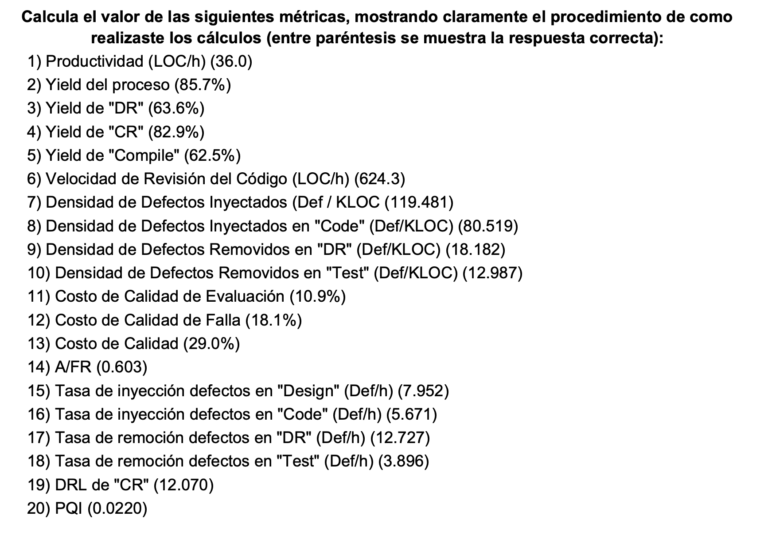

1. (345+40 )/(642 /60)
2. (29+7)/(31+11)
3. 7/11
4. (29)/(42-7)
5. 5/(2-29-7+31+11)
6. (40 +345 )/(37 /60)
7. 46/(345+40)*1000
8. 31/(345+40)*1000
9. 7/(345+40)*1000
10. 5/(345+40)*1000
11. (33+37)/642
12. (39+77)/642
13. (33+37+39+77)/642
14. (33+37)/(39+77)
15. 11/(83/60)
16. 31/(328/60)
17. 7/(33/60)
18. 5/(77/60)
19. (29/(37/60))/(5/(77/60))
20. A = 83/328 = 0.253

B = 33/(.5*83) = 0.795

C = 37/(.5*328) = 0.225

D = 20 / (10 + (5/((345+40)/1000))) = 0.87

E = 10 / (5 + (5/((345+40)/1000))) = 0.55

PQI = A * B * C * D * E = 0.0220

**Ejercicio 2**

1. (227+1)/(622/60)
2. (16+2)/(19+8)
3. 2/8
4. (16)/(19+8-2)
5. (5)/(19+8-2-16)
6. (227+1)/(47/60)
7. (28)/((227+1)/1000)
8. (19)/((227+1)/1000)
9. (2)/((227+1)/1000)
10. (5)/((227+1)/1000)
11. (53+47)/622
12. (50+31)/622
13. (53+47+50+31)/622
14. (53+47)/(50+31)
15. 8/(100/60)
16. 19/(266/60)
17. 2/(53/60)
18. 5/(31/60)
19. (16/(47/60))/(5/(31/60))
20. A = 100/266 = 0.375

B = 53/(.5*100) = 1.06 -> 1

C = 47/(.5*266) = 0.353

D = 20 / (10 + (5/((227+1)/1000))) = 0.626

E = 10 / (5 + (5/((227+1)/1000))) = 0.371

PQI = A * B * C * D * E = 0.0309